7-1 Final Project - Reflection
Sabrina Ozburn
CS-330 Comp Graphic and Visualization
10/19/2025

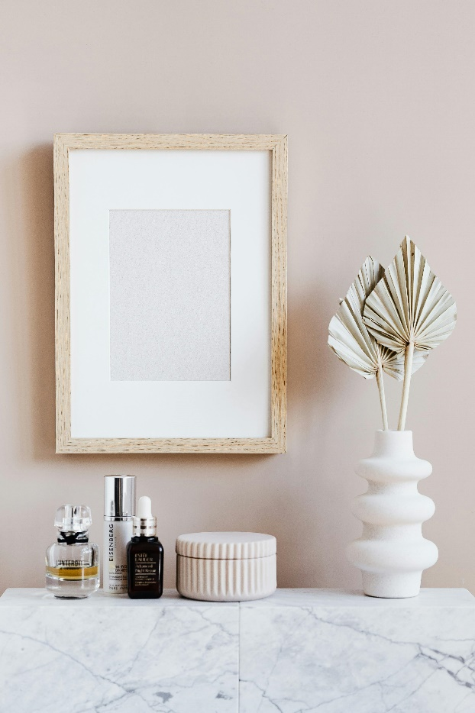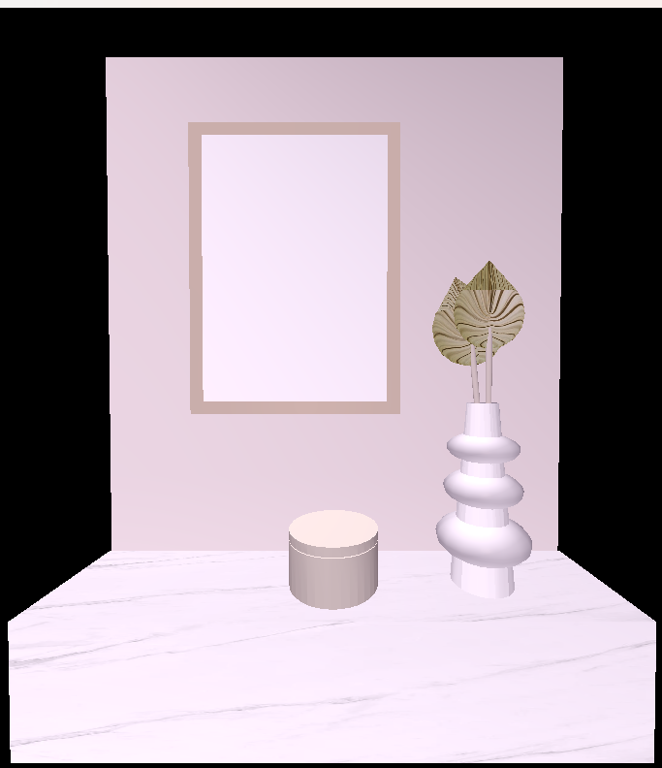
Original Rendered
1. Justify development choices for your 3D scene. Think about why you chose your selected objects. Also consider how you were able to program for the required functionality.
In designing my 3D scene, I chose to model a realistic tabletop arrangement featuring a table, a vase with palm leaves, a picture frame, and a round container. Each object was carefully selected to achieve visual balance and to showcase a range of geometric shapes and textures, while also evoking a natural, home-like setting.
- The table serves as the foundational surface, anchoring the scene and providing context for the other items. It’s a simple, flat geometry that also allows for explicit shadow casting and lighting interactions.
- The vase with palms introduces organic, dynamic forms that contrast with the more rigid geometry of the table and other objects. This choice highlights the use of more complex modeling techniques and adds visual interest.
- The picture frame was included to bring a personal and decorative element to the scene, while also offering a rectangular structure to complement the rounder shapes.
- The round container adds variety in form and shows how circular objects are handled in the 3D space.
To enhance realism, I applied textures to two objects: the palms, which feature an accordion-style design to emphasize their decorative purpose, and the table, which has a marble texture to resemble real-life materials. These textures not only make the scene more lifelike but also demonstrate my understanding of texture mapping in OpenGL.
2. Explain how a user can navigate your 3D scene. Explain how you set up to control the virtual camera for your 3D scene using different input devices.
Navigation within my 3D scene can be controlled using both the keyboard and the mouse. The mouse allows the user to adjust the camera angle by panning around the scene, enabling them to look in any direction, including left, right, up, or down. Scrolling the mouse wheel changes the speed at which the camera moves through the space.
Keyboard controls handle directional movement:
- W moves the camera forward
- S moves it backward
- A and D move left and right, respectively
- E moves the view upward
- Q moves it downward
By combining both mouse and keyboard inputs, users can easily explore and navigate the 3D environment with smooth, intuitive control.
3. Explain the custom functions in your program that you are using to make your code more modular and organized. Ask yourself, what does the function you developed do, and how is it reusable?
To keep my code modular and organized, I created custom functions that separate different parts of the program into manageable, reusable sections. I followed the structure and coding style demonstrated in the OpenGL tutorials and other course materials, which helped me stay consistent throughout the project.
One of the main approaches I used was writing separate code blocks for each 3D object, each placed within its own clearly marked section in the Render function. These sections were divided with lines of asterisks and labeled with descriptive comments, making it easy to identify which part of the code affects which shape. This not only made the code more readable but also easier to update or troubleshoot specific objects without affecting the rest of the scene.
Although I didn’t create separate custom functions for every object, I treated each section like a modular unit within the Render process. This structure could easily be turned into reusable functions later, such as a DrawTable() or DrawVase() function, if the scene were to grow more complex.
Overall, the organization helped me manage the scene better and allowed me to reuse layout styles and drawing logic across multiple objects. While I did find myself being overly focused on visual precision—trying to match the scene exactly to the reference image—I found the process enjoyable once I understood how to structure and control the code more confidently.

